**Hardwares and Softwares**

* PC Intel® Xeon(R) E-2276G CPU @ 3.80GHz × 12, Memory 32 GB, Ubuntu 20.04.4 LTS
* IoT Nodes: Texas Instruments CC2650 SimpleLink Ultra-Low Power Wireless MCUs, 128 KB Flash, 32KB RAM). SW: Contiki 2.7.
* Raspberry Pi 4: 4GB RAM and Raspbian OS
* Router Linksys E900. SW: Custom Firmware tomato E900-NVRAM64K-1.28.RT-N5x-MIPSR2-140-Max (Needed to add custom IPv6 routing table rules)
* Laptop: Lenovo G550 series with 3GB RAM and Core 2 Duo Processor and SW: Ubuntu 20.04 LTS OS (FOR INTRUDER)
* DHT Sensor for Temperature and humidity.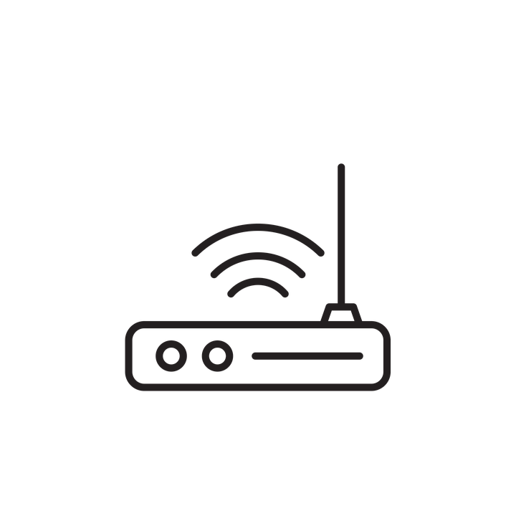





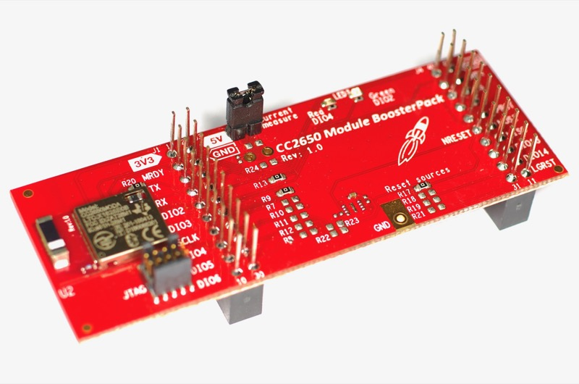

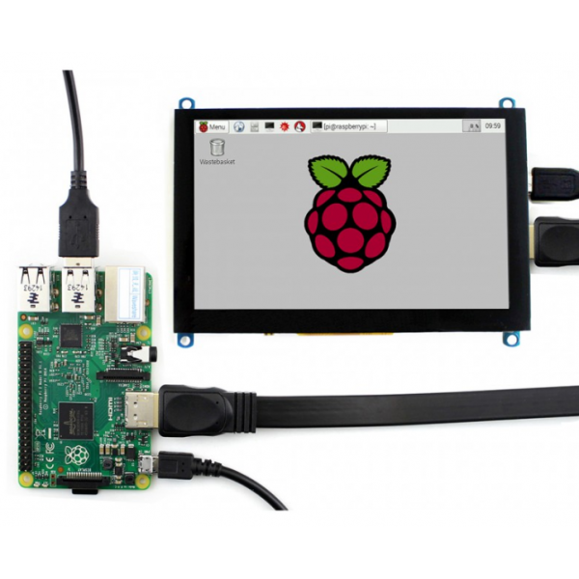

WiFi + Router 6LowPAN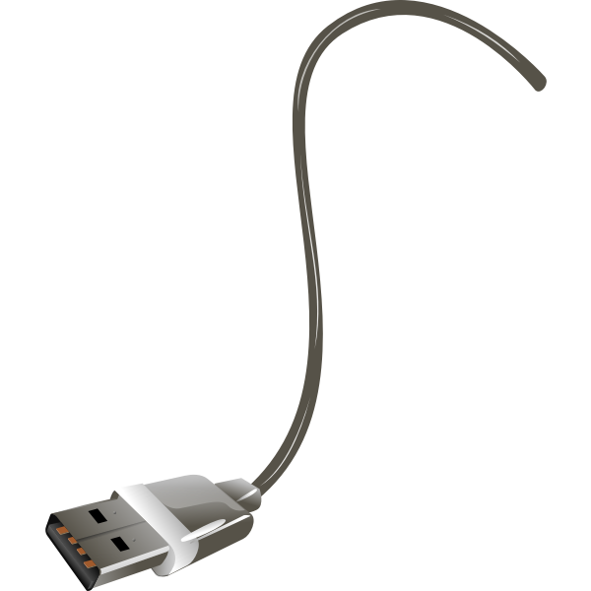

Network

HP PC

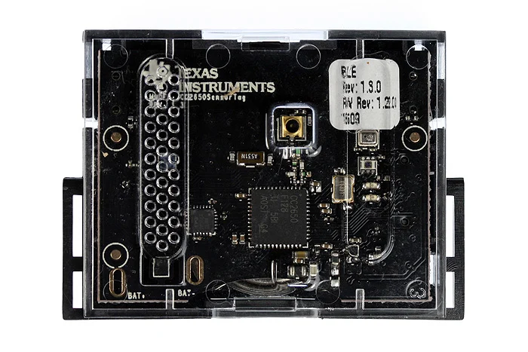



6LowPAN border router (root) cc2650 sensortag

[cc2650 launchpad + power bank

+ Raspberry Pi 4]

Attacker’s System